Chapter 20 programming

20.12:

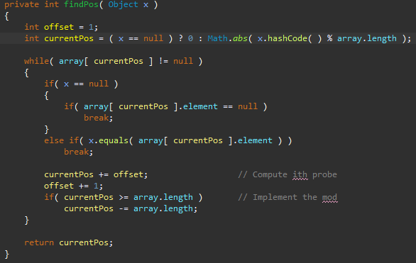

20.17:

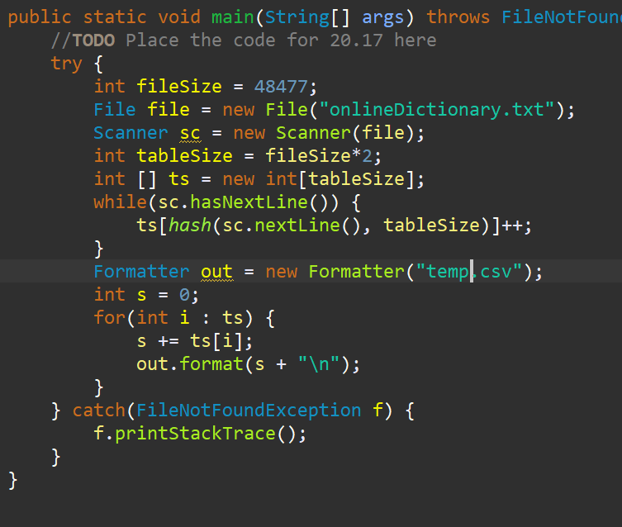

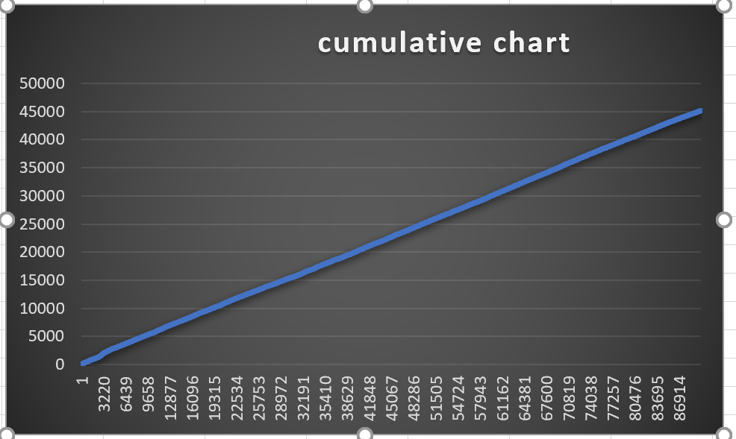

The way I did was with a sum formula in excel to get the cumulative chart. Compared to random it looks like a pretty good distribution.